**Review-3**

**Title -** Online Quiz Management System (web application)

**Team members -** Rishi Dinesh (19BAI1009), Pranav Balaji (19BAI1151)

**Abstract**

The process of conducting a manual examination is tedious and time-consuming. Examiners have to go through hundreds of answer sheets and meticulously grade every single one of them. Various online quiz management systems (QMS) have been developed to overcome this hurdle. However, these systems are mostly found as a built-in part of bigger E-Learning management systems like the Moodle. In addition to this, these QMS do not provide a forum for enthusiastic quizzers to interact and hone their skills.

The objective of the proposed system is to reduce the overlap between E-learning management systems and Quiz management systems and to build a community where users can create and attempt quizzes of various types shared by other users on the website. It proposes a standalone online quiz management system with an aesthetically appealing design and integrated group facilities that can be taken advantage of by institutions and organisations. It allows users to create their own quizzes with different types of questions, form groups and attend a variety of quizzes created by other users on the site. It is equipped with option-wise marking, negative marking and an auto grading system that makes the process of evaluating quizzes quick and efficient. It is also built with a two-way feedback system that can help bridge the gap between the quiz taker and the quiz organiser. Quizzes also come with a pdf export option that can be made use of whenever necessary.

Another main highlight of this system is the different available levels of visibility modes that introduces a form of abstraction into the system. Users can create quizzes containing both objective and subjective questions. Each quiz that is created is grouped under one of three visibility modes which can be changed by the quiz creator at any point of time.

Public quizzes are globally visible and can be attempted by any registered user on the website. Protected quizzes are also globally visible but are tagged with a unique identifier (a quiz code) and only those users with access to this quiz code can attempt these quizzes. Private quizzes are not globally visible and can only be attempted by the members of the groups that they have been added to.

**Introduction**

In the present-day scenario, many educational institutions are focusing on developing web-based virtual classrooms as an interaction place between the students and the teachers. This setting is useful not only in long-distance based learning but also in conventional classrooms, in the sense that these online web applications can also serve as a supplementary learning tool in many institutes. However, these systems focus mainly only on the teaching processes.

Testing is an important part of any educational system because the instructors use the test to evaluate the knowledge of their students. In addition to the conventional tests in the classrooms, many situations may require testing systems such as testing the applicants on their basic skills or knowledge before selecting one for an opening position in a company or testing the basic knowledge of a certain topic to become a certified expert on said topic.

It was observed that there was a yawning gap between the E-Learning platforms and E-assessment platforms in terms of both quality and quantity [1]. This brought about the need to develop an online evaluation platform to match with the growing trend in the number of Learning Management Systems (LMS).

In addition to this, it was also found that most of the currently existing Quiz Management Systems (QMS) were usually found as an integrated part of bigger LMS. The lack of independent QMS raised the need to develop this project as a standalone system [2]. Another reason for this independency is attributed to the lack of a widespread community for enthusiastic quizzers to share and attend quizzes to develop their skills.

Upon further exploration, it was uncovered that there was also a huge communication gap between the quiz organiser and the quiz taker owing to the lack of a two-way feedback system. Moreover, it was noticed that some of these systems had a rigid marking system i.e. features like negative marking and option-wise marking were absent.

A literature survey revealed numerous solutions proposed to tackle the various issues in the domain of online quiz management systems. [3] proposed two extensions (plugins) that could be installed to overcome the issues of network stability and quiz security. It was however limited only to the Moodle learning platform. [4] On the other hand proposed an offline web application with quiz synchronization that could enable students to view and work on quizzes offline and have their attempts updated when the device receives an internet connection. One particular paper [5] proposed an ingenious system based on point-to-point near field communication that could allow quizzes to be conducted on an Android platform.

This project focuses mainly on bridging the gap between the standards of LMS and QMS by developing a standalone quiz website with built-in visibility modes and integrated group facilities, and a flexible marking and grading system that can help make the process of conducting and evaluating quizzes easy and efficient.

**Proposed method**

*Website user flow*

On entering the website, the user will first encounter a landing page with a navigation bar containing the login and Signup buttons. The landing page will display the highlights of the website as a slideshow. If the user has an existing account, he/she can login with their credentials or choose to login using Google. A new user can either login with Google or create an account by clicking the Signup button.

After logging in, the user will be redirected to the dashboard. This is the main page of the website where the home page, list of all available quizzes, created quizzes and groups will be displayed. The entire page will be divided into a side panel on the left containing the above mentioned four options and the main display panel on the right. The page will be bordered at the top by another navigation bar that will contain the user’s unique ID, the View Profile button and the logout button. Clicking on the View Profile button will redirect the user to the profile edit page where the user can change/upload a profile picture, update their password or edit any of their other profile details.

Clicking on the Available Quizzes tab on the side panel will display all the public and protected quizzes on website in the main panel. Clicking on the Created Quizzes tab will display all the quizzes created by the user along with the Create Quiz option. Clicking on the Groups tab will trigger a dropdown in the side panel showing all the groups the user is a part of and a Create Group option. Clicking on any of the groups will display the group’s information in the main panel along with three tabbed sections: the Quizzes tab, which will display all the private quizzes associated with the group, the Members tab, which will display all the members of the group, and the Group Info tab, which will show the group’s information in an editable format.

Clicking on any of the available quizzes will trigger a modal dialog box displaying the quiz details along with two buttons: Attempt and Summary of Previous Attempts. Clicking on Attempt will take the user to the quiz’s attempt page. This page will display the quiz’s questions and allow the user to respond to each of them. The quiz ends with a submit which on clicking will submit the user’s responses and redirect him/her back to the dashboard. Clicking on the Summary of Previous Attempts button will take the user to a page showing a list of the same. Clicking on a particular attempt will display the quiz form with the related responses and the marks awarded. The auto grading system will have evaluated all but the descriptive type of questions. If the quiz creator has evaluated the descriptive questions, the total marks along with the comments given will be displayed. Otherwise, a message saying that the response has been sent for evaluation and that the marks will be updated once the evaluation is completed will be displayed.

In the Created Quizzes section, each created quiz will be displayed with four options: View Responses, Edit, Delete and PDF View/Export. Clicking the View Responses button will display the list of responses and allow the creator to evaluate any of them. Clicking the Edit button will take the user to the quiz edit page (very similar to the quiz create page) where any aspect of the quiz can be changed. The delete button will delete the quiz after a confirmation dialog box and the PDF View/Export will render the quiz in a PDF format that can be downloaded.

This section will also contain the Create Quiz button which on clicking will take the user to the create quiz page. This page will be divided into two columns. The left columns will contain the quiz create form and the right column will display the preview. Here, the user will first have to set the quiz name and select a quiz type from one of three options: open (public), code protected (protected) and restricted to group (private). This is to determine the visibility mode of the quiz as mentioned above. Selecting protected mode will generate a shareable quiz ID. If the user selects private mode instead, he/she will be prompted to enter the group code of the group(s) of which this quiz is a part. After this, questions (both objective and subjective) can be added to or removed from the quiz by clicking the Add New Question button or Remove Last Question button respectively. For each question, the user will be prompted to enter the question description, the question type (multi choice single correct, multi choice multi correct, true or false, descriptive), the number and values of the options and the correct option(s) (for objective type questions). Once done, the quiz will be created by clicking the Save button.

Clicking the Create Group button under the Group dropdown will trigger a dialog box prompting the user to enter relevant group details. Once the group has been created, it will be updated in the dropdown. Clicking on the group will display the group details along with the three tabbed sections mentioned previously. The Quizzes tab will display all the private quizzes of the group. The Members tab will display all the members. If the user is the admin of the group, he/she can add/remove members. He/she can also transfer the admin privileges to another group member. The Group Info tab will allow the admin to edit group information or delete the group. These features will be disabled for group members.

Clicking on the home button on the side panel will display a list of randomly selected quizzes and groups in the main panel along with a search bar at the top. This search bar will allow the user to search for other users, quizzes and groups.

*Module-wise explanation*

1. **Authorization**

**Creating an account (Signup and Login)**

An account for the user can be created using a provided email address, first name, last name and a password, which is encrypted and stored in the database. Multiple account creation using the same email address is prohibited, with login using third-party logins given an exception. There are no limits and conditions on the type and structure of the input details, although protection against *Injections* are handled and taken care of.

**Construction of the User Data**

*User = {userId, uniqueUserId, firstName, lastName, email, password, loginType}*

With the supplied information of *firstName, lastName, email* and *password*, a user is created in the database with an autoincrementing *userId*, a uniquely generated *uniqueUserId* which starts with the character ‘U’ followed by an octet of digits (CRC-32 random hash generation). The *loginType* is an Enum, and in this case, takes the value of ‘LOGIN’ for Quizzee account creation and login. The *password* is encrypted using a combination of *md5* and *sha256* encryption algorithms. The *uniqueUserId* will be used to access the user in further necessities.

**OAuth Login Authentication (Login)**

Login using Google has also been implemented for users who don’t like the hassle of creating new accounts for different sites, or for people who don’t want to maintain passwords for different sites. The user will be redirected to Google’s sign-in page, from where they can choose their account to login and proceed through the login procedure. The authentication will be handled by Google’s servers and the result of the authentication will be fetched and the required fields will be taken for password-less account creation.

**OAuth 2.0 Algorithm**

1. Instantiate a new *Google Client*from the Client Application with the required scopes (Scopes refer to the data that is permissible to access by the application)
2. Call the Google server for an *Access Token*, which is a short-lived JWT that can authenticate a signed user.
3. Instantiate a *Google Service* which can retrieve information about the user from the Google Server using the Access Token – *givenName, familyName and email.*
4. Close the connection to the endpoint and create a new User with the same process as before in the database, with the login credentials from Google server and *loginType* set to be ‘GOOGLE’.
5. **Quizzes**

**Create/Edit Quiz**

Creation of Quizzes is designed to have a very simple interface that involves minimal manual work from the user’s end. The user can choose a name for the Quiz to start with. Further, the group can be set as *Open* (Open to anyone), *Code-Protected* (Access via Quiz Code from the Quiz creator) and *Group-Restricted* (Access via the registered Group). If the group is set to be code-protected, then the user will be given a randomly generated quiz-code that must be entered by any attendee in order to attend the quiz. If the group is set to be group-restricted, then the attendee must be under the group in order to view and attempt the quiz. A single Quiz can be attached to multiple groups too.

The user then has the option to create multiple questions of 4 different types – *Multiple Choice Single-Correct (MCQ), Multiple Choice Multiple-Correct (MCMQ), True/False (TF) and Descriptive (D).* Every question requires a question description as a mandatory field. Also, there are no limits to the number of options that can be added to MCQ and MCMQ type questions. Every option requires an option description to be mandatory too. One of the options under MCQ, TF-types and more than one option under MCMQ-type questions can be set as correct options for evaluation. Every option can be given an individual mark which will be awarded if the attendee selected the corresponding option. Description type questions don’t have a correct answer, and is sent to the reviewer for evaluation. The quiz can be created only when all the description fields are filled. The visibility of the quiz will be limited to the mode of the quiz as per the user’s selection.

*Quiz = { quizId, uniqueQuizId, quizName, quizType, quizCode, createTime, creatorId }*

*Question = { questionId, questionNumber, questionDescription, questionType, quizId }*

*Option = { optionId, optionNumber, optionDescription, optionIsAnswer, optionWeightage, questionId }*

**Algorithm**

1. Create a quiz by supplying a Quiz Name
2. Choose the type of Quiz – *Open, Code-protected* or *Group-restricted.* The second option will provide a *uniqueQuizId*, with the same generation principle of the *uniqueUserId*, except that it starts with a ‘Q’. The third option will prompt for the groups to add the Quiz to.
3. Clicking on the *Add Question* button will create a new blank question. It contains a Question Description and a prompt for selecting the type of question.
4. There are 4 types of questions – *MCQ, MCMQ, TF and D.* Choosing each of the question types will bring about different following interfaces.
5. For MCQ and MCMQ, the user will be prompted to create options, which also require specifying the option description and the correct answer correspondingly.
6. The D type questions will create a textbox for the attendee to enter the answer into. It does not require any additional input from the user.
7. The TF type questions create 2 options – True and False and as such does not require any manual input from the user.
8. The quiz, questions and options will be generated in the above-specified format and stored in the database so.
9. Any of the above following settings can be edited by the creator whenever needed. The code of the Code-protected quiz will be updated on every subsequent edit to maintain closure.

For every subsequent quiz-format accessing from the database, the following route is employed: *quizId 🡪 questionId(quizId) 🡪 optionId(questionId)*

**View Quiz**

The created quiz can be explicitly viewed only by the creator. It displays the Quiz Name, (optionally Quiz Code or Groups attached to, depending on the abstraction of the Quiz) and the total marks obtainable. It also shows the list of questions and the correct options for each question. It is used as a reference and check for the creator, so that any changes can be taken over to Editing the Quiz.

**Attempt Quiz**

A Quiz can be attempted by anyone (constrained by the abstraction) except the Quiz creator. The Quiz can be attempted freely (Open), after supplying Quiz Code (Code-protected) or being in a group (Group-restricted) by the attendee. The input information is then authenticated and then the user is redirected to the attempt page. The quiz has no time restrictions and can be attempted as many times as needed. The quiz information is shuffled. Every attempt is recorded and responses are made visible to both the attendee and the Quiz Creator. The layout is almost similar to the Quiz Creation page but with options for quiz attempting.

*Response = {responseId, attemptNumber, userId, quizId, questionId, optionId, responseText?, responseWeightage, attemptTime}*

**Processing Attempts**

1. Attempt Quiz – optional Quiz Code in case of *Code-protected quizzes.*
2. Authorization of User and user-input for validation of the quiz attempt.
3. Quiz information processed and presented, following the earlier specified route of quiz information retrieval.
4. User can select options, fill in answers and then choose to submit the attempt.
5. Submitted information is processed and recorded as a Response in the database, with the details as mentioned above.

For every subsequent response-retrieval, the following methodology is employed:

*userId, quizId 🡪 response(userId, quizId) 🡪 questionId, optionId 🡪 question(questionId), option(optionId)*

**View Quiz Responses / Evaluation and Feedback**

* 1. **For Quiz Creator**

This feature is restricted to the Quiz creator. It shows all the responses to a particular attempt of a user for a quiz. The creator will be able to view the responses and marks obtained by the attendee. The creator also has the ability to provide the marks for any descriptive question in the quiz and provide feedback for any question (if needed).

* 1. **For Attendee**

The Attendee can view responses of an attempt of the quiz of choice. Marks will be updated as soon as it is updated by the Creator. Furthermore, feedback from the creator will also be shown here under the respective question, if any feedback was provided by the Creator.

*Feedback = {feedbackId, userId, questionId, attemptNumber, feedback}*

**Handling Responses**

1. Responses are displayed after being fetched using the above-mentioned retrieval process.
2. Responses are shown with the correct options, selected options, weightage for each answer and also additional feedback from the creator.
3. For *D* type questions, the creator has to manually evaluate and supply marks for the attendee to get complete marks.
4. Creator can send/update feedback and the feedback format is as specified above. It is then stored/updated in the database.

**Delete Quiz**

This feature is available only to the Quiz Creator, wherein the quiz and its associated attempts, responses and feedbacks can be deleted permanently.

Route for deletion of quiz: *Responses 🡪 Feedback 🡪 Options 🡪 Questions 🡪 Quiz*

**Export Quiz**

This feature is also restricted to the Quiz Creator. The Quiz can be exported in a PDF format for offline purposes. It contains the Quiz details, along with the instructions, question descriptions, checkboxes for options, space for descriptive answers and extra space for any additional space requirements.

Export feature is implemented using an external plugin to PHP called *FPDF.* It retrieves information to format using the same pathway as that of the quiz information retrieval.

1. **Groups**

**Create Group**

*Group = {groupId, uniqueGroupId, groupName, groupDescription, createTime, creatorId}*

*userGroup = {userId, groupId, role}*

Creating a group is a feature that is accessible to every registered user. The user can create a group with a Group name and a description. Creating a group immediately makes the creator the Admin of the Group. The group can be used to collect users under similar jurisdictions for quizzes. Only the Admin has control over the core features of the Group. The group is created using the input in the above-mentioned format.

Administrator roles will be handled using the following format:

*userId, groupId 🡪 userGroup(userId, groupId) 🡪 role (Default = Administrator, on group creation)*

**Add/Remove Members**

The Group Administrator has the privilege to add/remove users as members to the Group. A user can be added only once to a Group. The added members cannot edit the group information. Removing a user will also remove their quiz attempts from any group Quizzes.

**Algorithm**

1. Select the users to add using the dropdown-search box. Users can be found by using the *uniqueUserId* or their full names.
2. Click on the *Add Member* button to add the member to the group. This is handled via the *userGroup* entity, with the role initially set as *Member.*
3. Click on the *Remove Member* button to remove the member from the group. This is also done using the *userGroup* entity.
4. *Add/Remove Member* affects the entries in *userGroup*.

**Transfer Administrator Privileges**

The current Administrator can transfer the Administrator privileges to another member in the group. The current Admin will lose power over the group while the target member will gain access to full control over the group.

The *Make Administrator* button when clicked, transfers the admin from the current user to the target user. The process goes as follows:

1. Reset the current user’s role to *Member* in *userGroup.*
2. Change the target user’s role to *Admin* in *userGroup.*
3. Revoke the *Admin privileges* of the current user and supply the privileges to the target user.

**Add/Remove Quizzes**

*quizGroup = {quizId, groupId}*

Only the Group Administrator can add/remove Quizzes to the Group. Only the members that are registered under the group are eligible to attempt the Quiz. These Quizzes won’t be displayed to other users unless they are a part of this group. Attending these quizzes will follow the procedures of the other quiz types and there won’t be any extra measures/rules.

**Algorithm**

1. Create a quiz.
2. Select the *Group-Restricted type* for the group.
3. Select the Groups to attach the quiz to from the dropdown. Only the groups where the current user is the Admin will be displayed. Only the admin can add quizzes to the groups.

**Edit Group Information**

The Administrator can change/edit the details of the group – name and description. Other members of the group cannot access the feature and has to contact the administrator to make any changes to the group information.

This process updates the *groupName and groupDescription* of *groups,* for the changes to be registered.

**Delete Group**

Only the Group administrator can delete a group permanently. When a group is deleted, the associated quiz attempts, feedbacks and the members list will be lost forever. The attached quizzes will however still continue to exist irrespective of the group’s existence.

The process of removing a group has a cascading deletion-process as follows:

*quizGroup 🡪 userGroup 🡪 groups*

(Note that *quizzes* is not affected, which means that the quiz still exists and can be edited to attach to other groups or converted to any of the other 2 types)

1. **Search Bar**

The search bar is a feature implemented in the dashboard, which has a multipurpose functionality of finding quizzes, groups and/or users. It is a simple functionality but helps in getting the users connected with the application features.

**Algorithm**

1. Get the input from the user as to what to search for in the database.
2. If the input starts with the letter *U*, the user is searching for another user.
3. If the input starts with the letter *Q*, the user is searching for a quiz (except Grouped).
4. If the input starts with the letter *G*, the user is searching for a group.
5. The entered part of the input is matched with the corresponding elements of the database entries and the matched fields are displayed.

*Proposed diagrams*

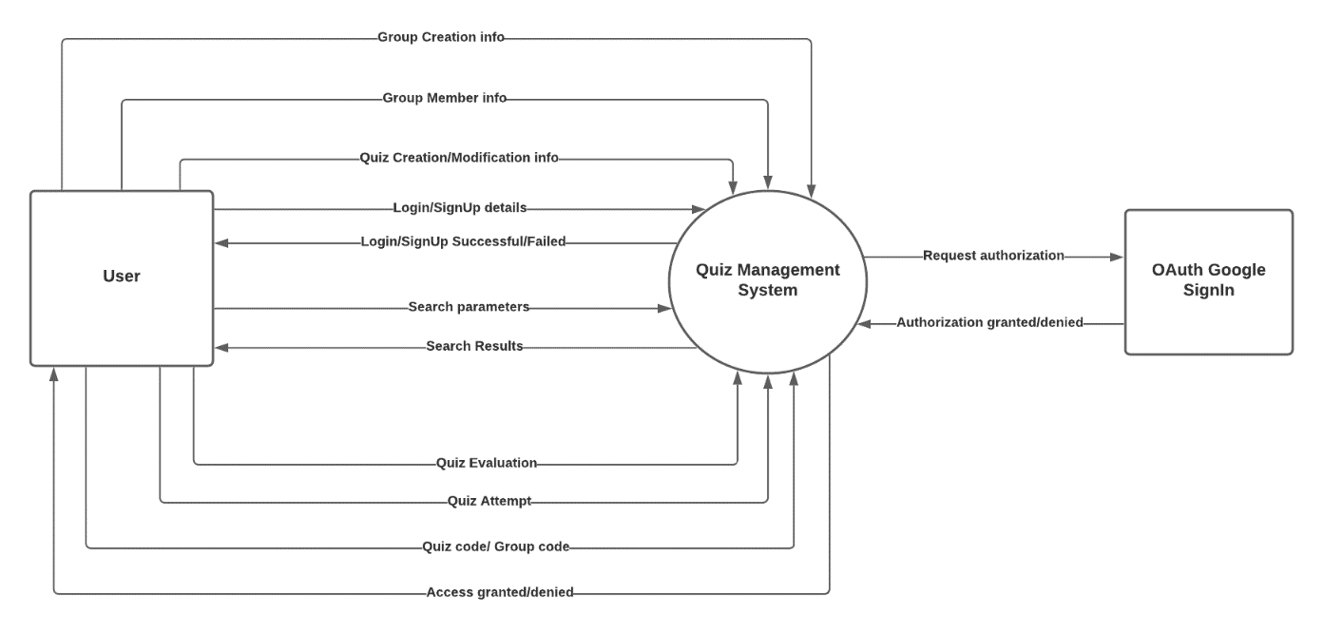

***Data Flow Diagram Level-0***

The above diagram shows a high level view (context diagram) of the flow of data into and out of the system. The system interacts with two main external entities, the user and the OAuth Google SignIn. The breakdown of the system into its various modules and their interactions with the databases is given below in the exploded view of the context diagram.

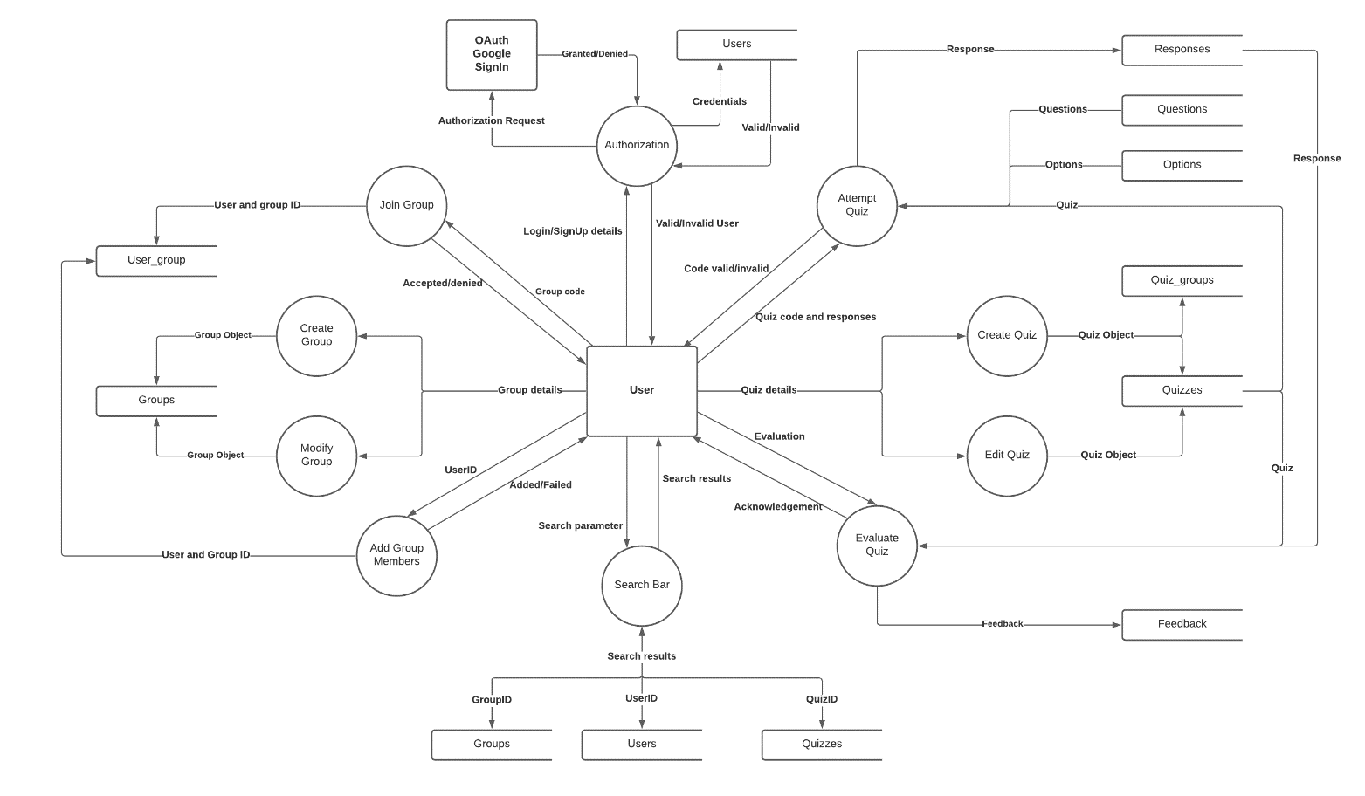

***Data Flow Diagram Level-1***

The above diagram depicts the various modules that the proposed system can be broken down into. The flow of data into and out of these processes have also been displayed. These processes interact with the backend database, which is also shown in the diagram.

**Hardware Requirements**

Since this project is a web application, it requires minimalistic hardware to run. The threshold is an i3 Processor based computer (or higher) with a memory of at least 1 GB and a hard drive storage of at least 50GB. It requires basic input and output devices such as a monitor, keyboard and mouse for navigation. The system must also be equipped with an internet connection to access the website.

**Software Requirements**

The only software required is a web browser such as Google Chrome, Microsoft Edge, Mozilla Firefox, Safari etc. This project will be developed to be platform independent and will thus be able to run on any browser-OS combination. Some recommended operating systems for a smooth user experience are the Windows version 7 or newer, macOS X v10.7 or higher or the popular Linux distribution, Ubuntu.

**Tools Used**

The front-end end of the website will be built with the classic combination of HTML, CSS and JavaScript. Bootstrap v4.0 will be used as an aid in the front-end design. The back-end of the website will make use of the Xampp software for development. This software will enable us to use the Apache HTTP server to run PHP as the scripting language and MySQL to build and manage the database.

**Screenshots (100%)**

Landing page of the website. Bordered at the top with a navigation bar containing the login and signup buttons.

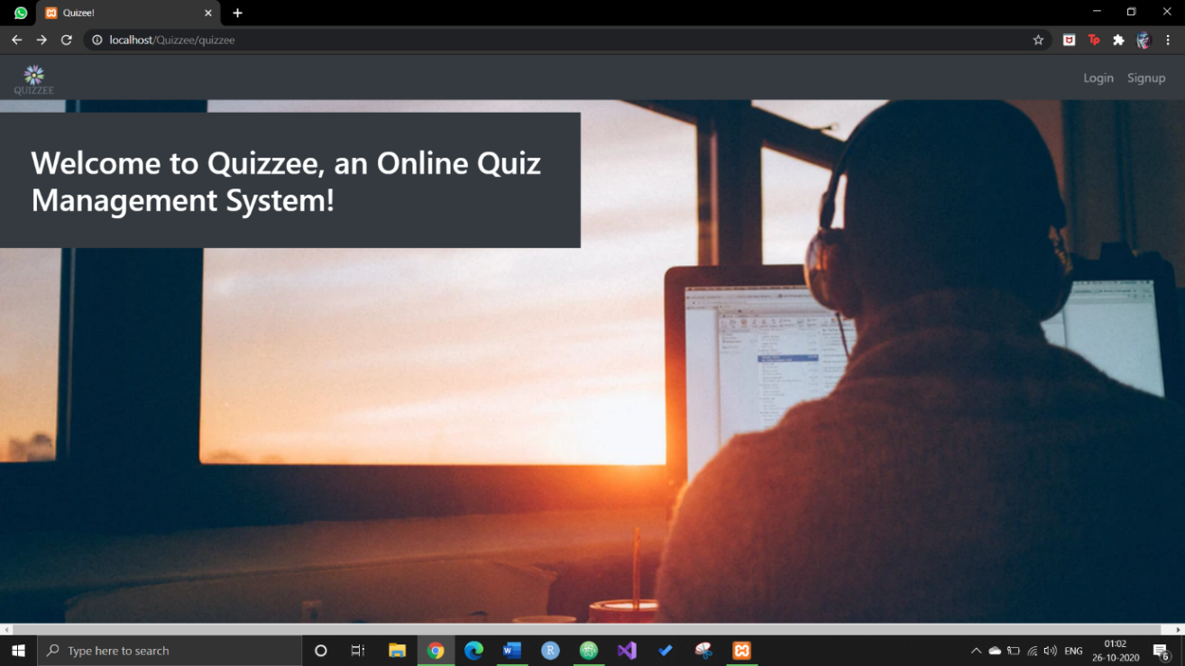

Login page with text boxes prompting for the email and password. Login with Google option also available.



Signup page with a form prompting the user to fill in relevant details to create an account. Signup with Google option also available.



The edit profile page of the website. User can change/upload a profile picture and edit account details.

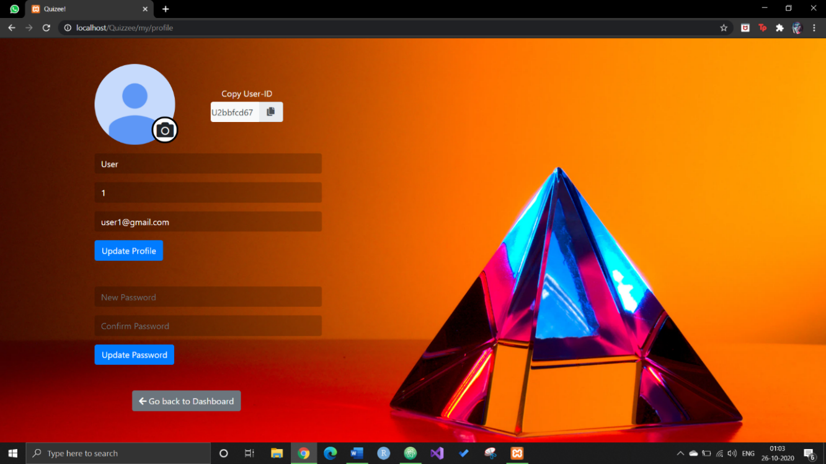

The user dashboard page with a side navigation panel displaying the main features of the website. The Home section displays a list of all available quizzes on the right as shown below.

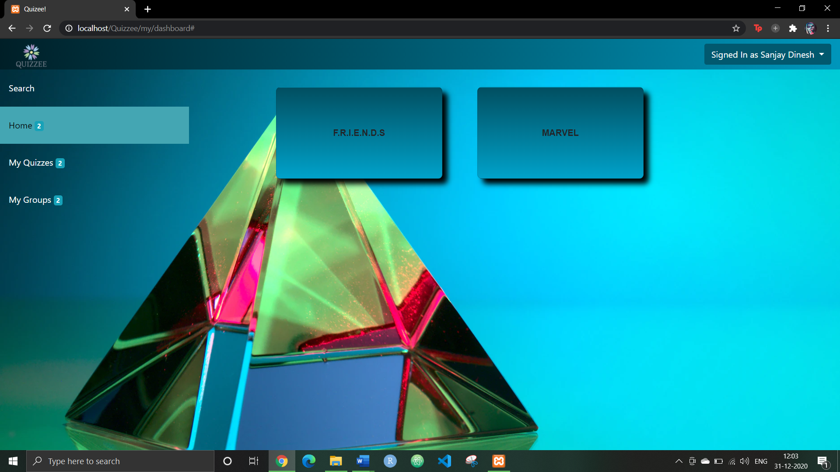

Clicking on the My Quizzes button will display a list of the same on the right along with a Create Quiz option. Each quiz will be displayed with four features: View Responses, Edit, PDF View/Export and Delete.

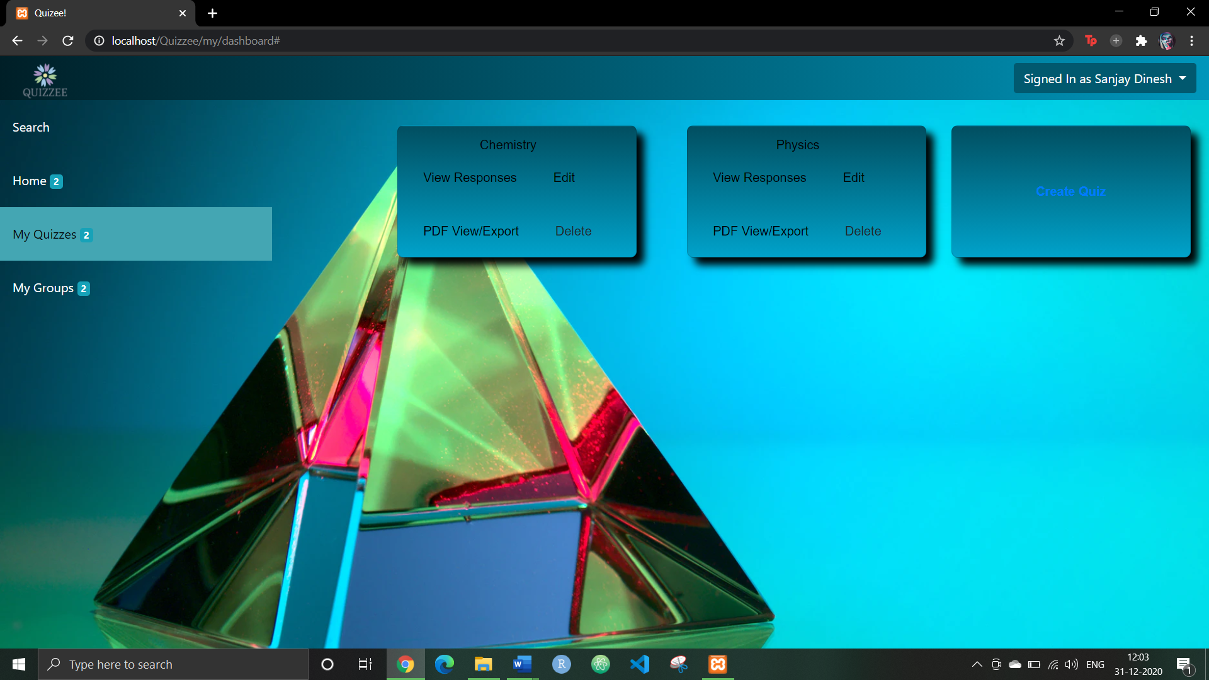

Clicking on the View Responses page displays a list of the same. The quiz creator can then evaluate any one of the responses.

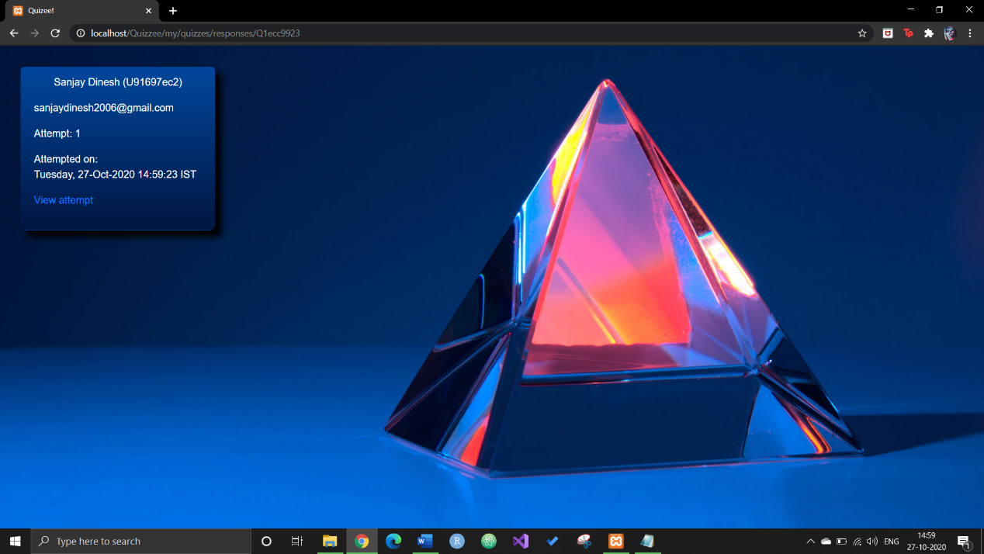

The auto grading system evaluates all but the descriptive questions. During evaluation, the creator can also send feedback for individual questions.

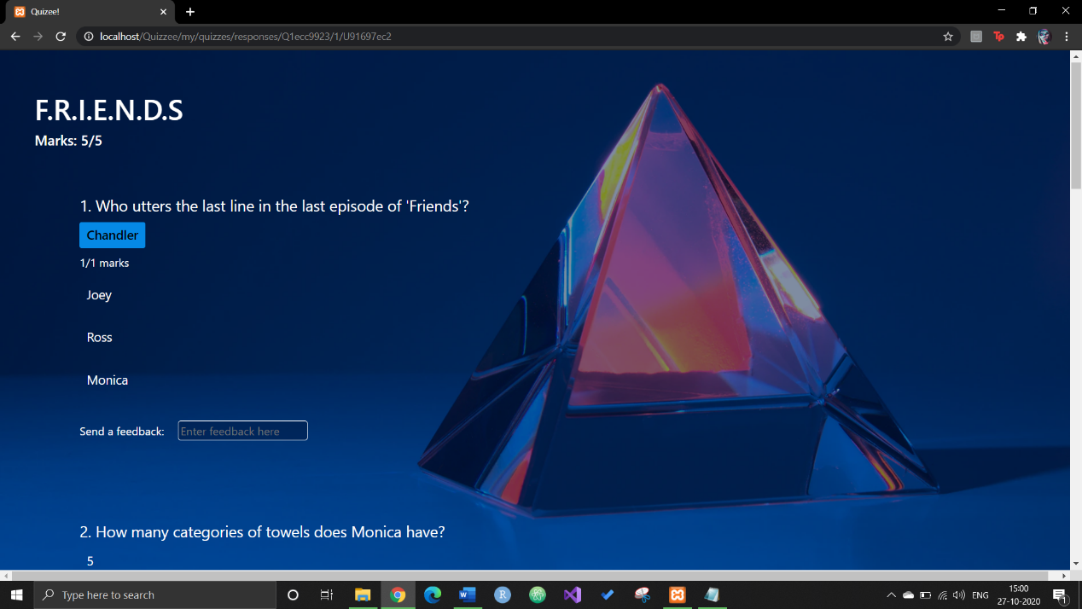

The PDF View/Export option renders the quiz in a PDF format that can be downloaded. This is useful when a quiz created on the site needs to be printed on paper and distributed manually.

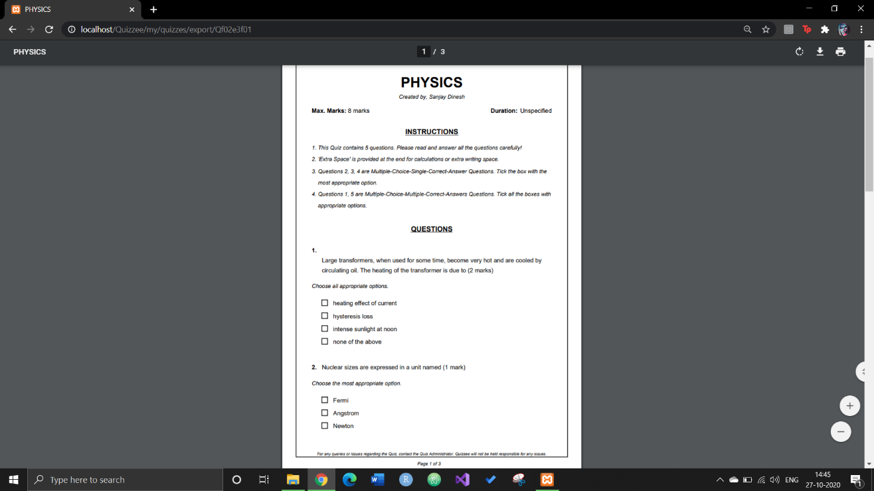

Shown below is a sample of the quiz attempt page. The questions and options are randomly shuffled for every attempt.

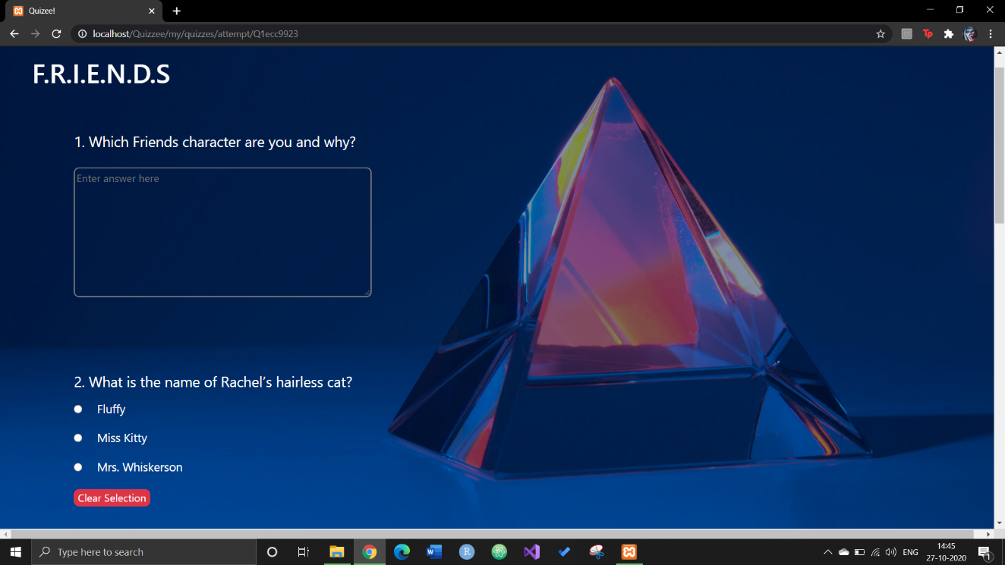

The user can also view a summary of all previous attempts for any given quiz. By clicking on an attempt, he/she can view the scores and the results of the evaluation.

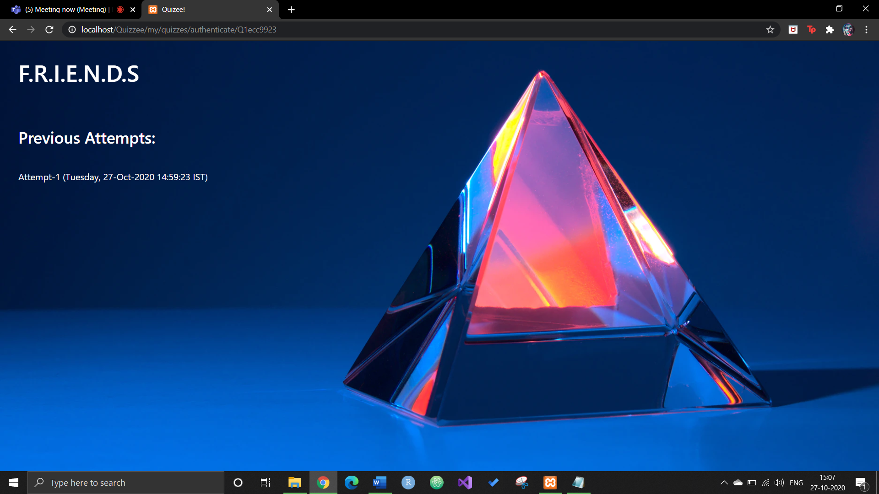

Users will be prompted for a quiz code in case the quiz is code protected.

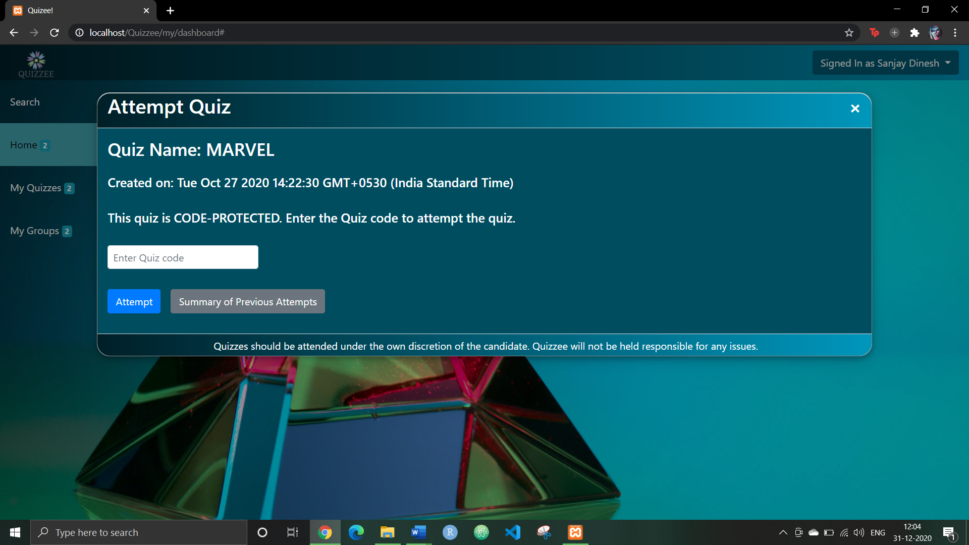

The Create Quiz option (and the Edit Quiz feature) is structured as follows. The user has to select a quiz name, quiz type (visibility mode) and fill out the question description, question type and option details for each question. The user can also see a preview of the quiz being created on the right.

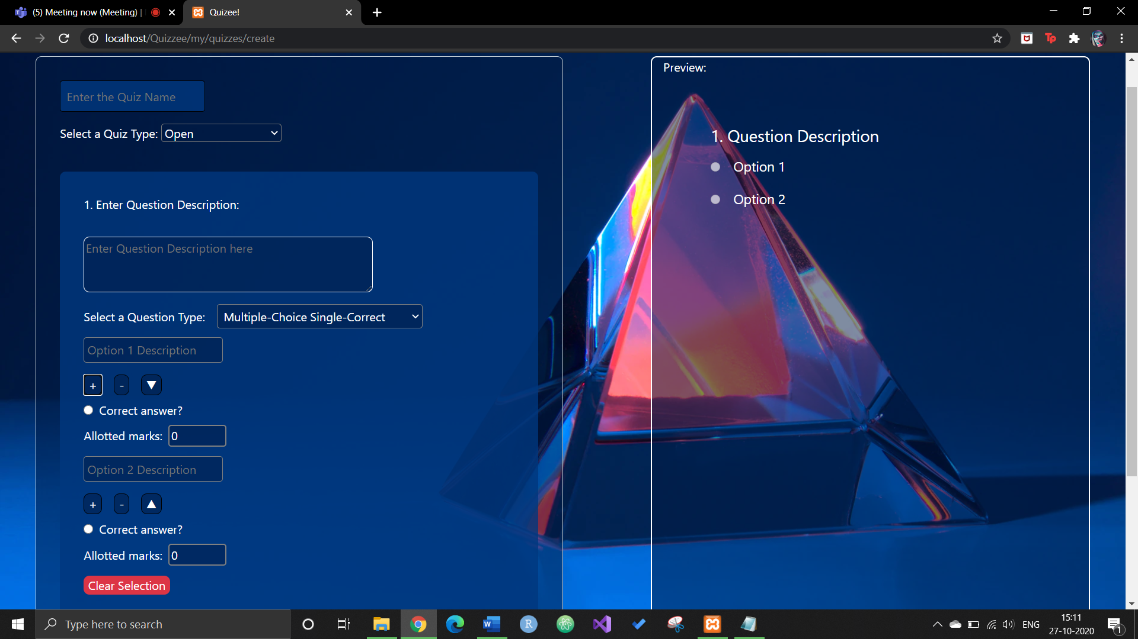

Clicking on a particular group from the group dropdown will display the group details with three tabs: Quizzes, members and Group Info. The quizzes tab will show a list of all private quizzes associated with that group.

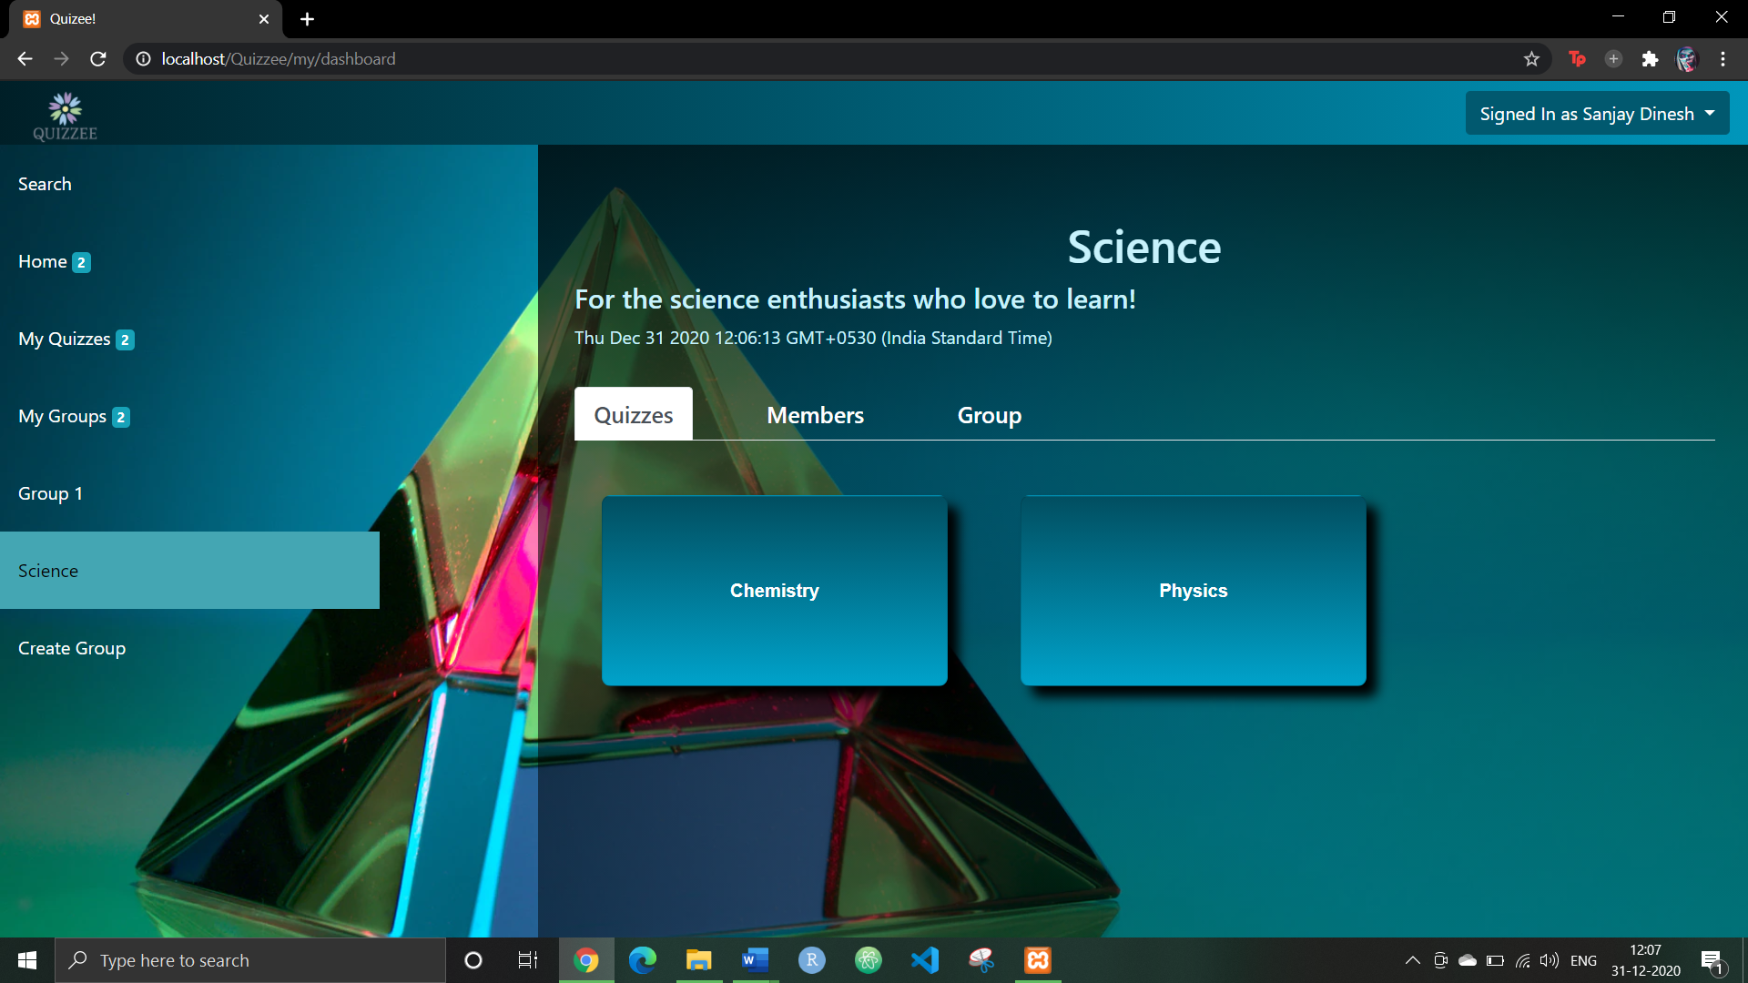

The members tab will list out all the members of the group. The admin of the group can add/remove members or transfer admin privileges to another member. These features are hidden for the other group members

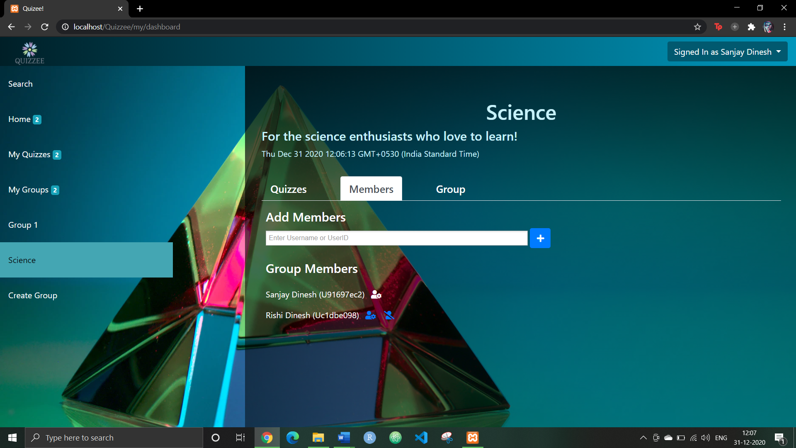

The Group tab will display the group’s information in an editable format. This is only accessible to the admin and is disabled for other group members.

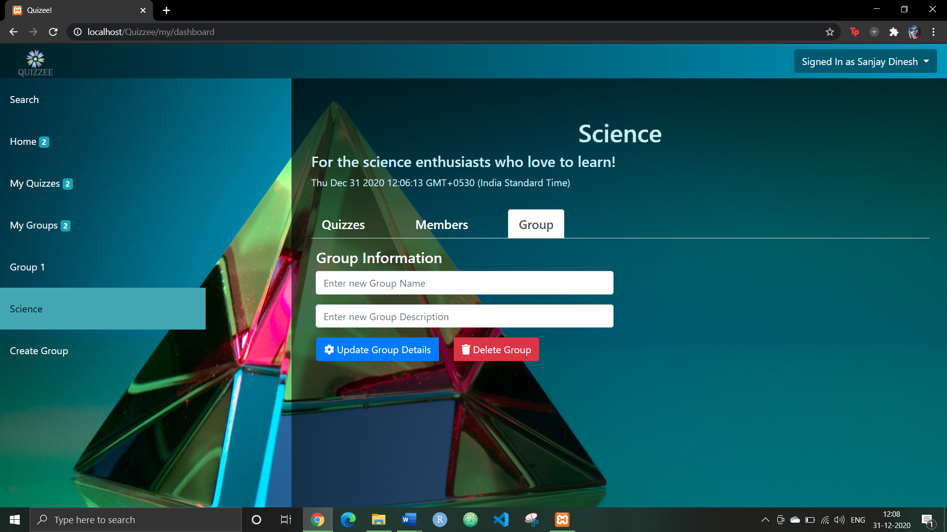

Clicking on the Create Group button at the end of the dropdown will trigger a modal dialog box prompting the user to enter the group details.

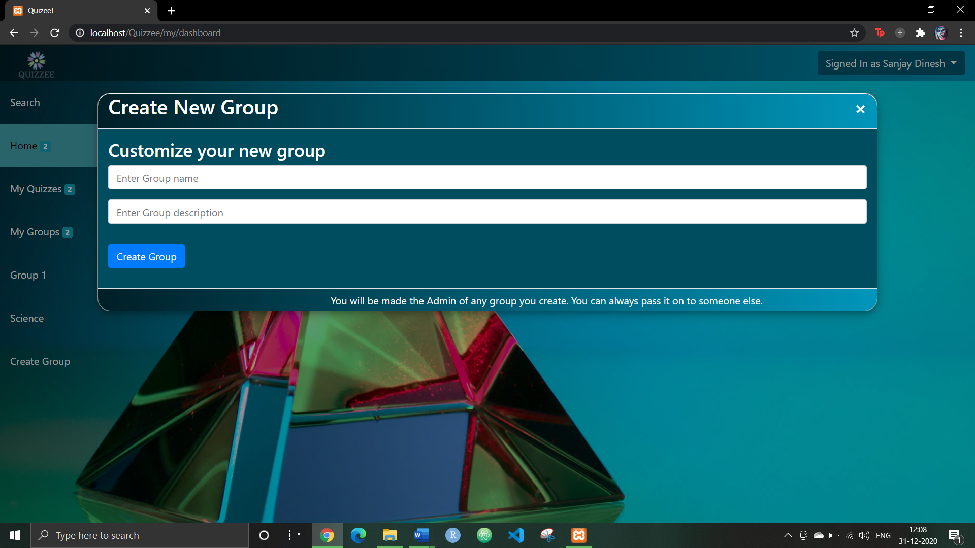

Finally, clicking on the Search button will trigger a search bar that allows users to search for quizzes, groups or other users.

The search results for a user includes the user’s profile picture (if set), username, first name, last name, email along with the user’s unique user ID.

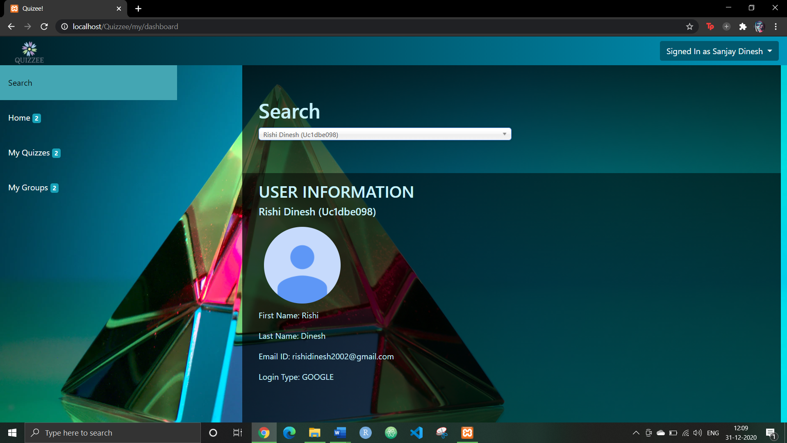

The search results for a quiz includes the quiz name, quiz type, quiz creator name, date of creation and the quiz’s unique quiz code.

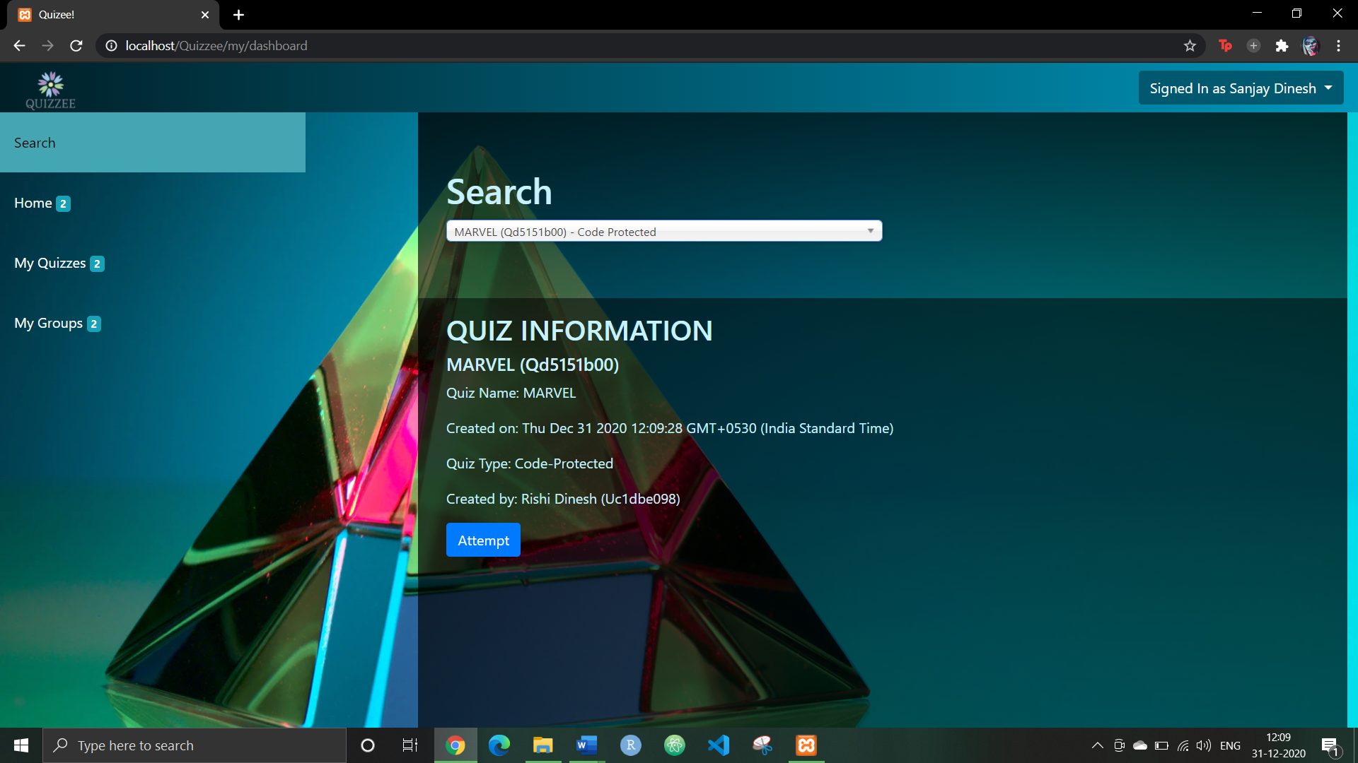

The search results for a group includes the group name, the group description, admin info, group creation date, the members list and the group’s unique group code.

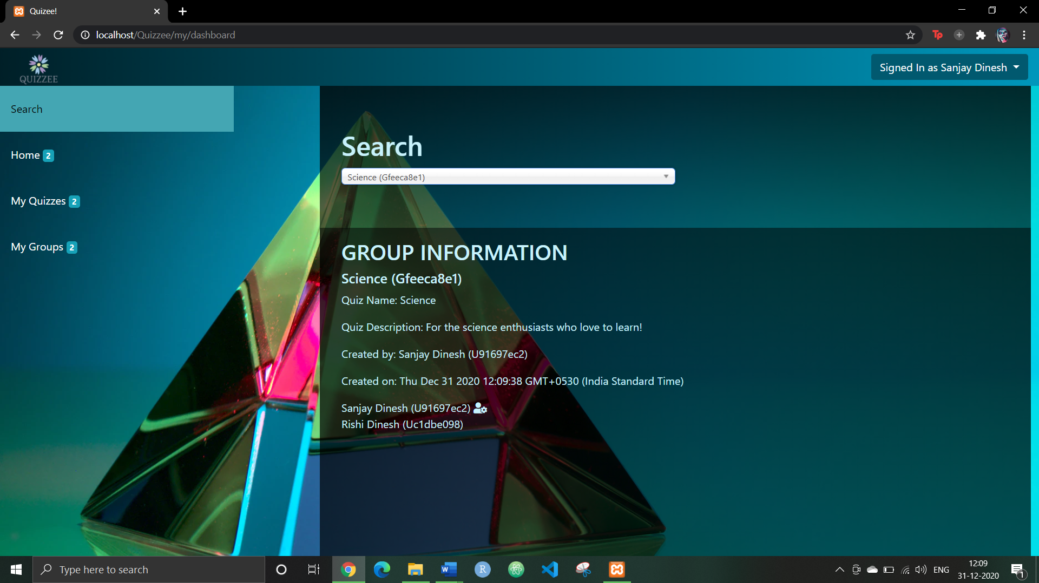

**Performance Analysis:**

Every sub-module and dependency in the application is subjected to unit-testing with detailed and comprehensive testing on various levels. The database is also checked for validity, constraints, integrity and normalization adherence. There is a fine balance between demand and performance in the application, ensuring a smooth user experience without any compromise on the features. The code is also optimized so as to allow future revisions easier and makes integration with other plugins much easier. We employed the *Spiral Model* for our software development process methodology – we came up with weekly revisions and ensured that performance in any module is not compromised.

Unit testing in the fields of both *state-based* and *interaction-based* testing have been employed here. Every submodule is subjected to both these tests comprehensively. Every independent submodule is tested well to ensure stability, and coherence when working together with other submodules.

E2E testing is also designed for this application as a whole, which serves as a reliable indicator to the overall working capacity of the application. A few of the test cases include: login & signup functionality tests, quiz creation tests, group creation tests and quiz attempt tests. Overall test results exceeded our expectations in meeting user’s requirements.

The application also has an inbuilt load testing mechanism, which can monitor and log the server load for potential future enhancements.

**Future Scope:**

* More prompt types – calendar, color picker, image selector, select dropdown, match the following, pinning images, etc.
* Better communication between the examiner and the student.
* Overall GUI enhancement.
* Offline data backup and recovery.
* Enhanced user profile and social network sign ins.
* Enhanced quiz recommender system.
* Extra group features.
* Email and notification facilities.

**Conclusion:**

Existing applications had a few common lacunae – like absence of 2-way communication between examiner and the student and dependance on a Learning Management System - to name the most notable ones. This application is designed in a way, where these lacunae are addressed as immediate concerns, along with enhancements to the user experience. It is also worth noting that at the immediate level, there is no provision for image-upload and image-related questions, additional group functionalities and few other minor features. However, in future revisions, we hope to include revisions to old features as well as a few new features like image-compatibility, group invitations, question types, email statistics, etc. Overall, the application is designed well to combat the above-mentioned shortcomings of other existing QMSs and it does well in its job too.

**References**

1. S. Vasupongayya, T. Kamolphiwong, S. Kamolphiwong and S. Sae-Wong, "Interactive examination management system," 2010 2nd International Conference on Education Technology and Computer, Shanghai, 2010, pp. V2-55-V2-59, doi: 10.1109/ICETC.2010.5529435.
2. M. S. Abood, M. Ismail and R. Nordin, "A quiz management system based on P2P near-field communication on Android platform for smart class environments," 2016 International Conference on Advances in Electrical, Electronic and Systems Engineering (ICAEES), Putrajaya, 2016, pp. 83-88, doi: 10.1109/ICAEES.2016.7888014.
3. Behamanush, Hamayoon & Thakur, Babita & Daniyal, Vivek & Sharma, Dr. (2018). A Project on Online MCQ Quiz Application. 10.13140/RG.2.2.10583.83369.
4. A.Y. Elmaghrabi and S. M. Eljack, "Enhancement of Moodle learning Management System Regarding Quizzes Security and Stability Problems*,"*2019 2nd International Conference on Computer Applications & Information Security (ICCAIS), Riyadh, Saudi Arabia, 2019, pp. 1-7, doi: 10.1109/CAIS.2019.8769530.
5. R. M. Ijtihadie, Y. Chisaki, T. Usagawa, H. B. Cahyo and A. Affandi, "Offline web application and quiz synchronization for e-learning activity for mobile browser," TENCON 2010 - 2010 IEEE Region 10 Conference, Fukuoka, 2010, pp. 2402-2405, doi: 10.1109/TENCON.2010.5685899.